Thank you for shortlisting me for an interview.

- I am Krishna Kishore. I did my Graduation in compute Application.
- I have completed the M.B.A information system.
- Since then, I have been working in the software industry.
- Currently I am working with Kyndryl. Earlier I worked in Cognizant, Wipro, and Polaris.

Hello, I'm Krishna Kishore.
- I’m experienced with various cloud technologies. However, I am more aligned with Azure.
- As an Azure data engineer/Architect.
I have a strong background in design, implementing and managing data solutions on the Microsoft Azure platform
- Over the past few years, I am helping organizations transform data strategy to cloud technologies to build scalable, secure data ecosystems.
- Involving full project life cycle and specialized architecture solution include components MS Fabric, Azure data lake, Synapse/Azure data factory/Azure data bricks
- Designed and implemented conceptual, logical, and physical data models for enterprise-level solutions using tools like ER/Studio
- Created dimensional models (Star/Snowflake schema) to support reporting and analytics in Azure Synapse /Fabric/Oracle/SQL Server/ Power BI

DATA Architecture roles and responsibilities:
- Interact with stake holder and understand the business goals and objectives.
- Understand source systems
- Define data discovery, data validations, data cleaning, data transforming, data aggregating and data loading rules.
- Define data governance rules, data security rules.
- Define schema required,
- Create Physical Model, Logic Model and Conceptual model.
- Translating Business requirements into database, data warehouse.
- Collaborating with other teams within the organization to implement strategies.
- Conducting a continuous audit of data management system performance, refine whenever required, and report immediately any breach or loopholes to the stakeholders.

Project management:
I am responsible to manage the project. Such as
- Project scope
- PMO Activities (Project management office)
- Milestones
- WBS (Work break down structure)
- Base line
- Prepare KANBAN Boards (Regular pieces of work)—Fixes. (TO be done/Planning/design/Active development/testing/signoff)
- Stake holder management
- Triangle balance (Time, cost, quality)
- RACI Chat: allocation of resources. Responsibility/Authorizty/consult/inform
- PREPATE Gantt chat: Activities/tasks vs Time
- CCB (Change control board)

Strength:
I am hardworking, consistent, and optimistic nature and quick learner.
I am optimistic person, I tend to be team oriented and trustworthy, as I never miss my deadline

Weakness
Easily trust others and I am more emotional.

Right now I am looking an opportunity where I can broaden my skills, experience along with my creative problem solving skills

What is your salary expectation?
I have been working as Data architect for 15 years. Completed so many certifications and awards. I want to earn a salary between 32 to 35.I came up with this number by calculating average market standards. This range seems to be reasonable.

Project descriptionExternal Project)

- Torex Gold is mining company in Canada and Mexico. Medialuna is one of the site contains Gold, Copper and Silver mineralization.
- We have implemented Medilian archtiechture for 2 projects one is EDW implementation for Torex Gold and MML(Mineral Media Luna)
- Torex using SAP ERP for day to day activities. We wanted to implement EDW on top of SAP/SF (Fail taks/Validate)
- From SAP, Torex Internal team pushing the files(Such as Costcentre/Company/Custer area/department/Division/glaccount into ADLS Gen2/Paygrade) etc.
- All pipelines are running using Meta data such as Config,Lineage,Errors to move data from BronzeSilverGold
- SF Apis . using rest Api we are connecting and move data to ADLS Bronz: Silver:Gold
- Excel files using Web Activity in data flow move into BronzeSilverGold
- Onpremise SQL
- Responsiblit to create Workspace, Lakehouse, warehouse ,Devops setup , Fabric deployment etc
- Cost report by cost centre,inventory, purchase order, Sale report etc. All dimensions reports. etc

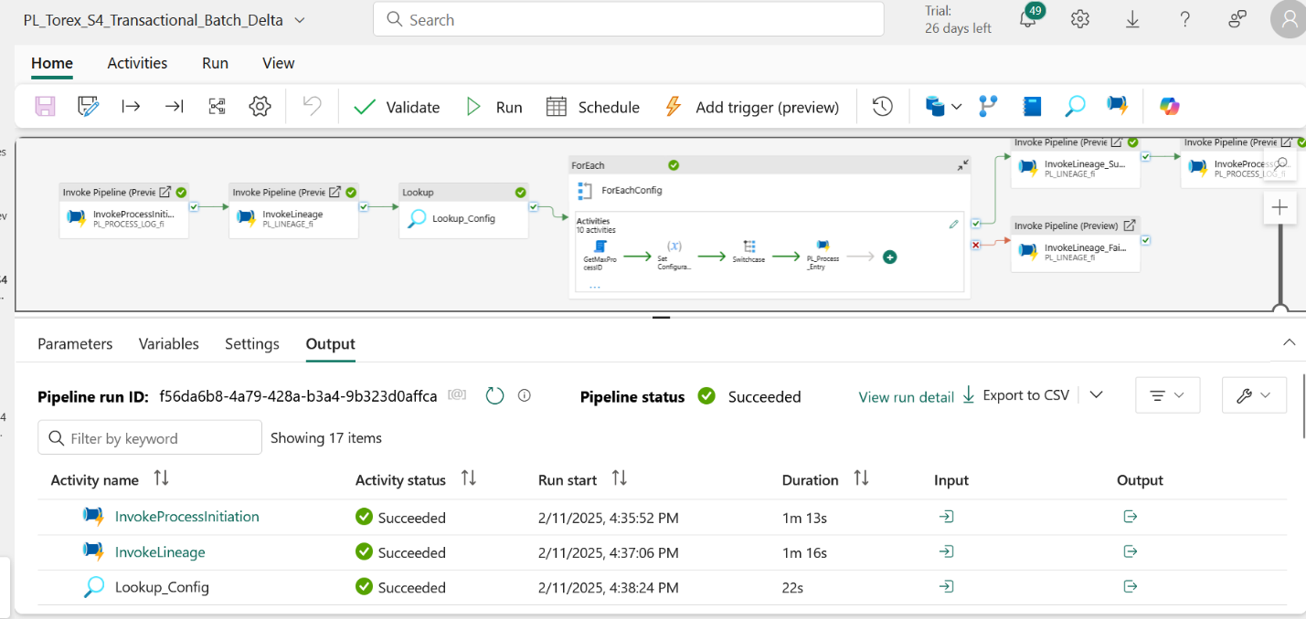

LAB3 :
I used to handle 2 projects internal as well external.
Internal Project: Pricing Calculator internal to LAB3
External Project: CDH/PDH/TEP Enterprise warehouse implementation for one of Australian bank.
Pricing Calc: Project came as part of POC/Ideate. Pricing cal is automated process to move pricing cal Entities to Kimble sales force API. Here Entities nothing but Elements/Assignments/Engagement/Milestone Rev/cost etc.

Technically
- we have bunch of CSV Files Elements/Engagement/Milestone) in share point portal. Logic app runs background to look share point location and ingest these files into Azure data lake location.
- ADF is orchestration process to look these files every day end of Australia time based on system date . Do all transformations and load into Azure synapse Analytics for reporting generation.
- also these data convert into JSON format (using json value function) and call Sales force APIS to load into Kimble Sales force tables.
- Reason storing in synapsis dedicated pool is to generate historic reports as well to handle failover activities.
- I have created Project scope, Milestones, Work breakdown, Base line, Git hub creation, workspace creation, Prepare KANBAN Boards (Prepare KANBAN Boards (Regular pieces of work)—Fixes. (TO be done/Planning/design/Active development/testing/signoff)
- Stake holder manager, Triangle balance (Time, cost, quality),
- Development/Update confluence on development progress, UAT tesing,Dev ops deployment on ADF/Scripts promotion etc.

- Current project which I am working on TEP/CDH/PDH: integrations.

- What time we purchase the product
- What product we purchased.
- What is the quantity?
- From which warehouse purchased
- Price of the product
General Data Protection Regulation

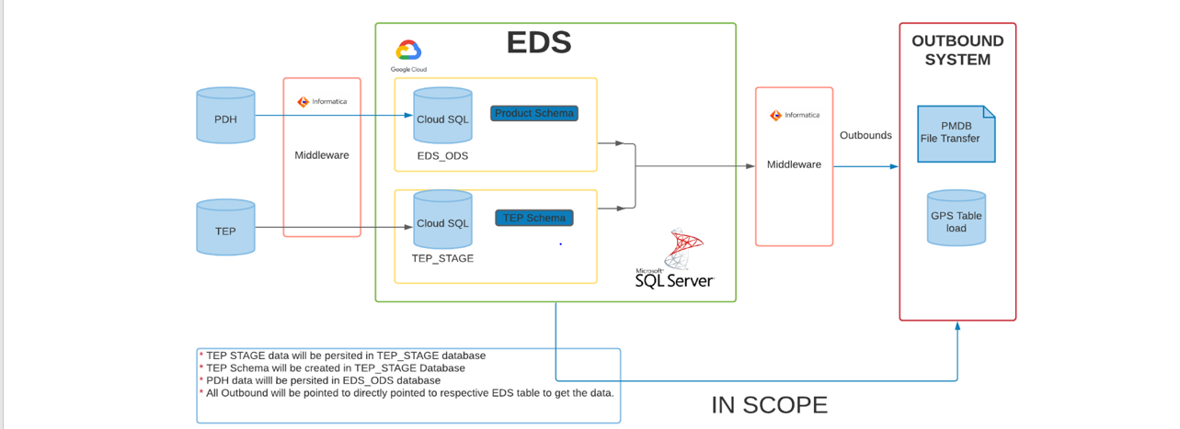
CDH:
- CDH is nothing but Customer data Hub. Where we have all customer related tables
- Extract the data from On Premises SQL and Sales force tables and load into Azure Lake. we do ETL transformations and load into Azure Blob.
- From Azure blob read the data and load into Stage area. post that we are using Merge statement and load into Final Customer tables.
- From there we have generate the files based on reporting requirement.

PDH:

- PDH also similar architecture additionally we have few more filters.

TEP:
- Here TEP is transaction enabled program (TEP is the Source System) where we are getting Transaction date which is in Oracle Hybris server. We read the ORACLE data and load into landing area. Which in Data Lake.
.

CDH TABLES:
ACCOUNT
ACCOUNT_SITE
ACCOUNT_SITE_USAGE
CONTACT_POINT
CONTACT_POINT_EXT_SYS_REF
DUP_SETS
DUP_SET_PARTY
EXTERNAL_SYSTEM_REFERENCE
OPERATING_UNIT
ORG_CONTACT_POINT
PARTY
PARTY_CLASSIFICATION
PARTY_CLASSIFICATION_CATEGORY
PARTY_ELIGIBILITY_DETAIL
PARTY_EXT_SYS_REF
PARTY_RELATIONSHIP
PARTY_RELATIONSHIP_TYPE
PARTY_SITE
PARTY_SITE_EXT_SYS_REF
RELATIONSHIP_CONTACT_ROLE
SITE_USAG

PDH TABLES:
EDS_ODS.PRODUCT
EDS_ODS.PRODUCT_FULFILLMENT_PROFILE
EDS_ODS.COURSEWARE_FULFILLMENT_PROFILE
EDS_ODS.TEP_STAGE.LEGACY_CODE
EDS_ODS.TEP_STAGE.INVENTORY_ITEM
EDS_ODS.TEP_STAGE.PRICE_LIST_CA_REF
EDS_ODS.TEP_STAGE.TEP_MTL_SYSTEM_ITEMS_B
EDS_ODS.TEP_STAGE.TEP_MTL_CROSS_REFERENCES_B
EDS_ODS.TEP_STAGE.ITEM_COSTS

EDS_ODS.PRODUCT
EDS_ODS.INVENTORY_ITEM
EDS_ODS.PRODUCT_CONTRIBUTOR_ASSOCIATION
EDS_ODS.LEGACY_CODE
EDS_ODS.CONTRIBUTOR
EDS_ODS.INVENTORY_ITEM_PRICING_ATTRIBUTE
EDS_ODS.PRICE_LIST_LINE
EDS_ODS.PRICE_LIST
EDS_ODS.PRICE_LIST_DESCRIPTION
EDS_ODS.PRODUCT_FULFILLMENT_PROFILE
EDS_ODS.PCS_SOURCE_CODE
EDS_ODS.COURSEWARE
EDS_ODS.PRODUCT_MANUFACTURING_SPEC
EDS_ODS.TEP_STAGE.ORGANIZATION_INVENTORY_ITEM_COST

TEP TABLES:

TEP table Name
TEP_HZ_CONTACT_POINTS
TEP_RA_BATCH_SOURCES_ALL
TEP_RA_RULES
TEP_CSI_ITEM_INSTANCES
TEP_HZ_CUST_ACCOUNTS
TEP_HZ_ORIG_SYS_REFERENCES
TEP_HZ_CUST_ACCOUNT_ROLES
TEP_HZ_RELATIONSHIPS
TEP_HZ_CUST_PROFILE_CLASSES
TEP_HZ_CUSTOMER_PROFILES
TEP_HZ_CUST_SITE_USES_ALL
TEP_RA_CUSTOMER_TRX_ALL
TEP_HZ_PARTIES
TEP_RA_CUST_TRX_TYPES_ALL
TEP_FND_LOOKUP_VALUES
TEP_FND_USER
TEP_OE_ORDER_HEADERS_ALL
TEP_OE_ORDER_SOURCES
TEP_GL_LEDGERS
TEP_CSI_I_PARTIES
TEP_HZ_CUST_ACCT_RELATE_ALL
TEP_XXPSO_INV_ADDITIONAL_ATTRS
TEP_XXPSO_ONT_CUST_ELIG_CONTACTS

CRoss Industrial Standard Process for Data Mining (CRISP – DM)
Sample, Explore, Modify, Model and Assess (SEMMA)
Knowledge Discovery Databases (KDD) process model
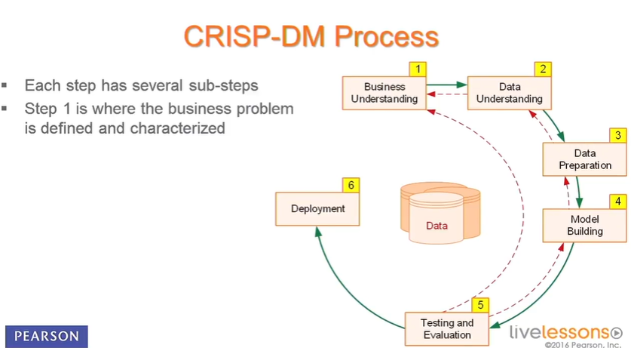
1. Business Understanding – Define Business Problem, Assess and Analyze Scenarios, Define Data Mining Problem, Project Plan
2. Data Understanding – Data Collection, Data Description, Exploratory Data Analysis, Data Quality Analysis
3. Data Preparation – Data Integration & Wrangling, Attribute Generation & Selection
4. Modelling: Selecting Model Techniques & Model Building, Model Evaluation and Tuning, Model Assessment
5. Evaluation
6. Deployment
7. Benefits realisation
8. Control Plan

- What time we purchase the product
- What product we purchased.
- What is the quantity?
- From which warehouse purchased
- Price of the product

What are critical challenges projects you did in your experience?
- Technology related challenges.
- CDC implementation in GGL (Masking customer data when we look from offshore profile). Every day we get master files where we have customer data . these customer data can be linked to all products(Mark to markets/Trade bal/instruct etc). I was the architect/design/developing/implementation of that project.

- Meriva postings redesign: Concurrent execution implementation (Understand existing architecture, created multiple sessions/workflows for the same source data)

- ROW Generator transformation upgrade to Java. Earlier it is c++ Library.

- Data lineage implementation for migrating code from Informatica to ADF as well regulatory report (No hard code account) scanning

- Automation of Feed processing, testing etc.

For all project I have creating design, development, implementation etc.

- Resource/Team structure related challenges
- Cognizant: Attrition and technology difference in project
- Working procedure related challenges
- Sprint and Scrum methodology difference
- Tools related challenges
- PLSQL Developer tools
- Communicate challenges.

Why we are going Cloud ?
No large capital expense, No hardware maintenance, Scalability, cost, integration with other service, MPP and time to market.

Why are you moving from Company?

- First and foremost, important is there is no clarity on work
- I am looking more into technical side. However, most of my time spending into project management. (SLA Preparing/Budget updating/coordinate with team member)/Other systems which I am not aware/depends on the TEAM
- Basically, we have 2 teams here. ESB/ETL. Difficult to manager ESB team as I am expert on ESB services.
- There is lot of attritions, people are moving out from organization however my senior management is not updating to the client. Because of this we have so much pressure and work.
- Also, I am managing Aws TO Azure migration .70% Work completed. Slowly we are handover the work to OPS team. (Managed by Client itself). They are not ready to take the handover.

